Public Address (PA) System 6 Zone Mixer Amplifier with Bluetooth
FA-60R/FA-120R/FA-240R/FA-350R/FA-500R
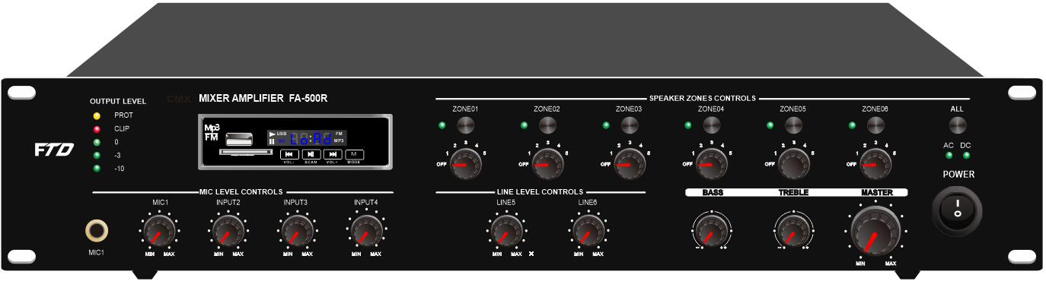

Description:

The PA 6 Zone Mixer Amplifier with MP3 and FM tuner, its rated power output from 60W, 120W, 240W, 350W to 500W,
it is ideal for school, super market, bank, hotel BGM and speech use. It is all in one solution with two sources, preamplifier and mixer power amplifier into one 19” 2U height unit, which is economy but of high reliable performance.

It integrates 2 audio sources into a mixer amplifier, plus Mic1(6.3mm) and Mic/Line input 2-4 (XLR), two line inputs,
one EMC input and one RS45 input for 6 zone remote paging microphone.
Mic1 VOX with highest priority except EMC input. One USB and one SD slots on front provide easy access and operation for installer and end-user.

The amplifier is design with complete protection of overload, short circuit and high temp to avoid any damage.

These amplifiers are suitable for applications in bank, mosque, school, hotel, restaurant, theme centers and shopping center.

Features:
- Public address (PA) 6 zone commercial mixer power amplifier.
- 19” rack mount amplifier of 2U height.
- Rated outputs of 60W, 120W, 240W, 350W to 500W.
- 6 zone speaker outputs of 100V or 70V.
- Six zone speaker outputs with independent volume control.
- Built-in MP3 player by USB & SD and FM tuner and Blue tooth
- Four microphone inputs, Mic1(6.3mm) and Mic/Line input 2-4 (XLR).
- Line 1-2 inputs on rear panel by RCA.
- EMC input on rear panel with highest priority by RCA.
- One amplifier capacity of 6 remote paging microphones FA-60RM up to 300 meters.
- Microphone1 of VOX features of highest input priority except EMC input.
- Volume control for Mic1-4 and line 1-2, bass & treble and zone volume control on front panel.
- AC and DC Power, protection, clip six zone status indicators and output level meters.
- Overload, short circuit and high temp protection.
- AC 230V and DC24V operation system.

Public Address (PA) System 6 Zone Mixer Amplifier with Bluetooth
FA-60R/FA-120R/FA-240R/FA-350R/FA-500R

Rear Panel:
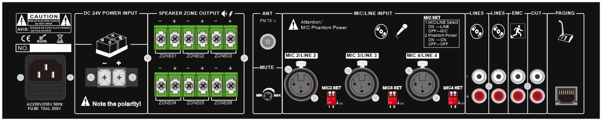

Specification:

Model | FA-60R | FA-120R | FA-240R | FA-350R | FA-500R
Description | Public Address System 60W Mixer Amplifier
Rated Power Output | 60W | 120w | 240w | 350w | 500w
Speaker Output | 70V, 100V, 6 zone speaker out 100V
Input | Mic1-3: 600 ohms(Ω) 5-8 mV, unbalanced, Line1-2: 10k ohms(Ω) 150-470 mV,  unbalanced
Frequency Response | 60-15KHz
THD | <0.5% at 1kHz, 1/3 rated power
S/N Ratio | Line: 85 dB , MIC: >72 dB
Protection | High temp, short circuit, overload protection
Power Supply | AC230V or AC110V, 50-60Hz
Power Consumption | 100W | 200W | 400W | 500W | 600W
Dimension | 418(W)×318(D)×88(H)mm
Gross Weight | 8.2kg | 9.5kg | 2kg | 13kg | 14.5kg
Warranty | 5 years

Support Remote Microphone:
